32 VOICE RECORD/PLAY BACK MODULE

GENERAL DESCRIPTION

WTV-SR is one of the members of recording serial products. WTV-SR module can record as well as fixed voice playback, recording content uploaded and a variety of control modes can be chosen. With the master chip and plug-in SPI-FLASH, it has a great advantage in the duration time of recording and cost performance.

PRODUCT DESCRIPTION

WTV-SR is provided with mp3 mode, Key control one by one, parallel interface, one-line serial interface, three-line serial interface. Therefore, WTV-SR module is suit for many occasions. It can be changed different control modes by setting I/O, which on the bottom of WTV-SR. It gives a Flexible power supply by either supply module or supply solution, so it is a effective recording solution.

The recorded voice can be uploaded to the system. It also supports download voice from PC and play recorded voice with high quality. It can record up to 252 segment voice (including fixed voice) and recording time up to 1600 seconds. It supports audio recording at 10 KHz or 14 KHz sample rate.

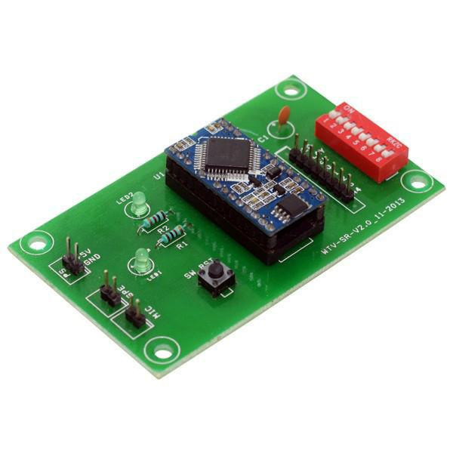

32 voice record/play back module

FEATURES

- Operating voltage: 3.3v DC

- Recording Time: 12 minutes

- 8-level adjustable volume

- Support MIC & LINE-IN recording

- Support USB with programmer

- With power down memory to retain

APPLICATIONS

- Telephone recording systems

- Industrial control toys

- Home appliances

- Remainder

- Learning machine

